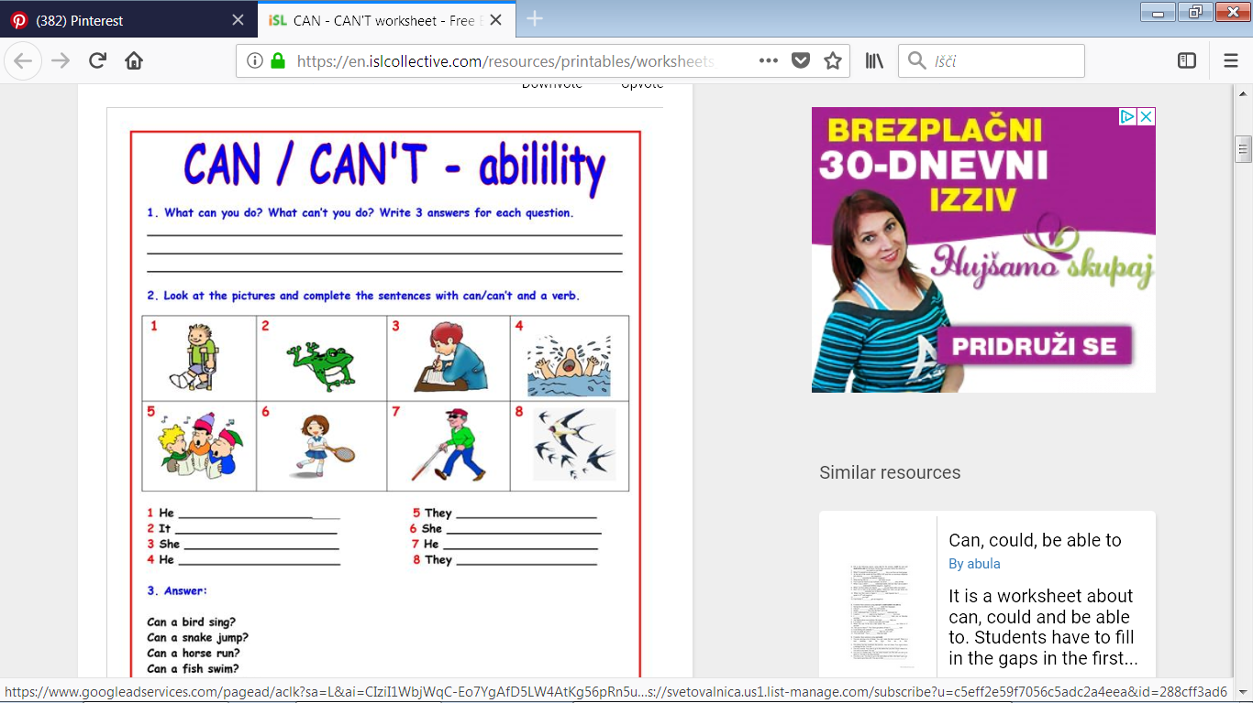

|  |  |  |  |
| --- | --- | --- | --- |
| Povezana slika**1.**  **Mary** | Rezultat iskanja slik za can't play tennis**2.**  **Tomas** | Rezultat iskanja slik za can surf clipart**3.** Rezultat iskanja slik za can't swim  **John** | **4.**  **Emily** |
| **Rezultat iskanja slik za can't play tennisRezultat iskanja slik za can run5.**  **David** | **6.**  **Daniel** | **Rezultat iskanja slik za can cycle clipartRezultat iskanja slik za can ski7.**  **Lisa** | **8.**  **Jason** |

1. Mary can play basketball. 5. David can't play football.

2. _________________________________. 6. _____________________________.

3. _________________________________. 7. _____________________________.

4. _________________________________. 8. _____________________________.

|  |  |  |  |  |  |  |  |
| --- | --- | --- | --- | --- | --- | --- | --- |
| **run** | **ski** | **ride a bike** | **surf** | **swim** | **play football** | **play tennis** | **play basketball** |